Day 1: Assignment-2 (Java Programming Fundamentals)
Name: Suraj Arya | PRN No.: STT-25128071920
Q1. Write a Java program to declare and initialize all 8 primitive data types and print their values.
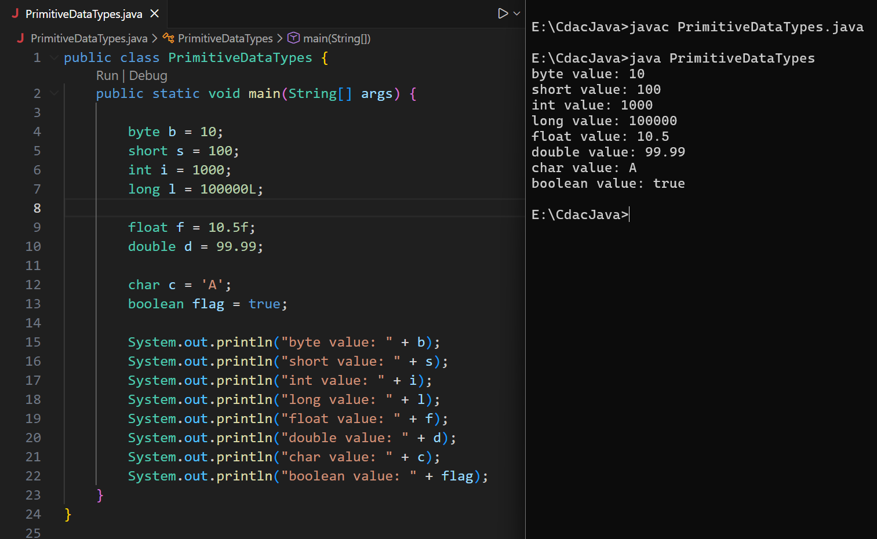
Ans:
Q2. Write a Java program to create a final variable(Constant) for the value of PI, assign it 3.14
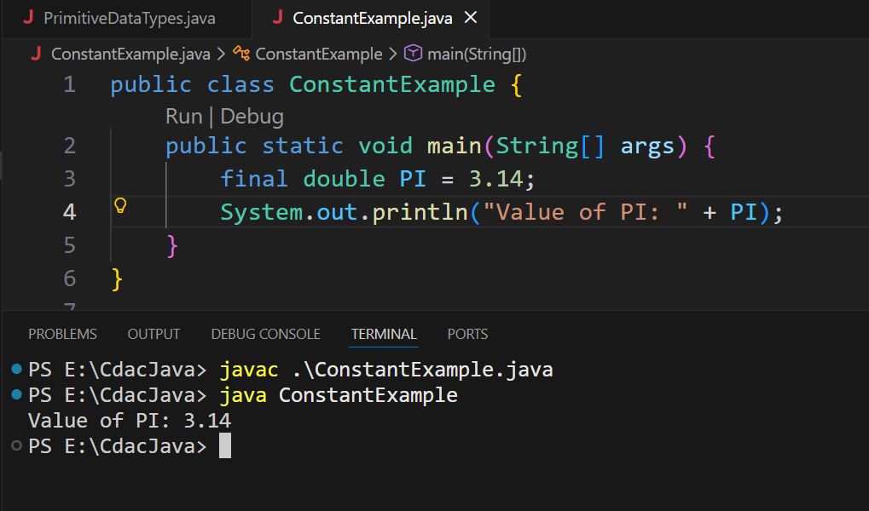
Ans:
3. Write a program using var (Inference) to declare variables of types: int, double, char, and boolean. Print their values.
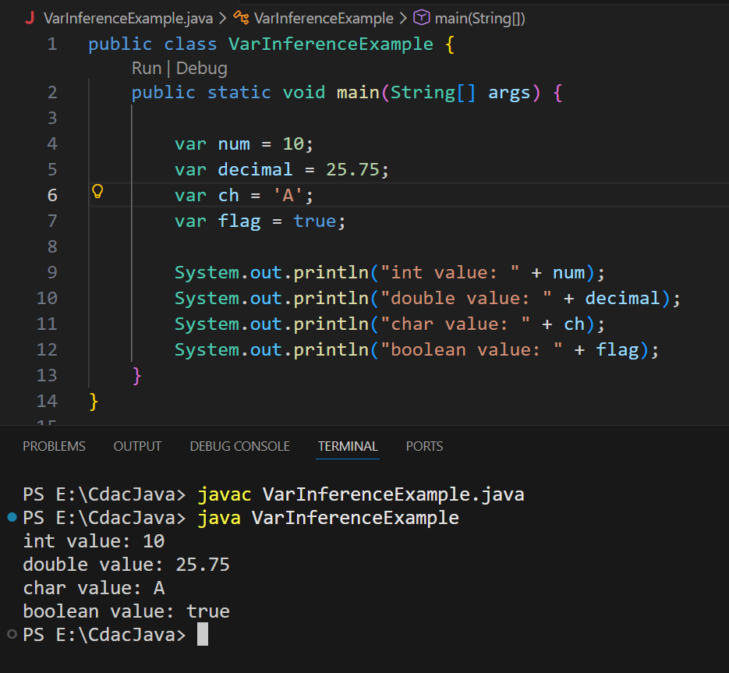
Ans:

Q4. Write a Java program to demonstrate implicit type conversion (widening) in the following two cases:
- From int to double
- From long to float.
- Declare and initialize an int and a float variable.
- Assign them to double variables without casting.
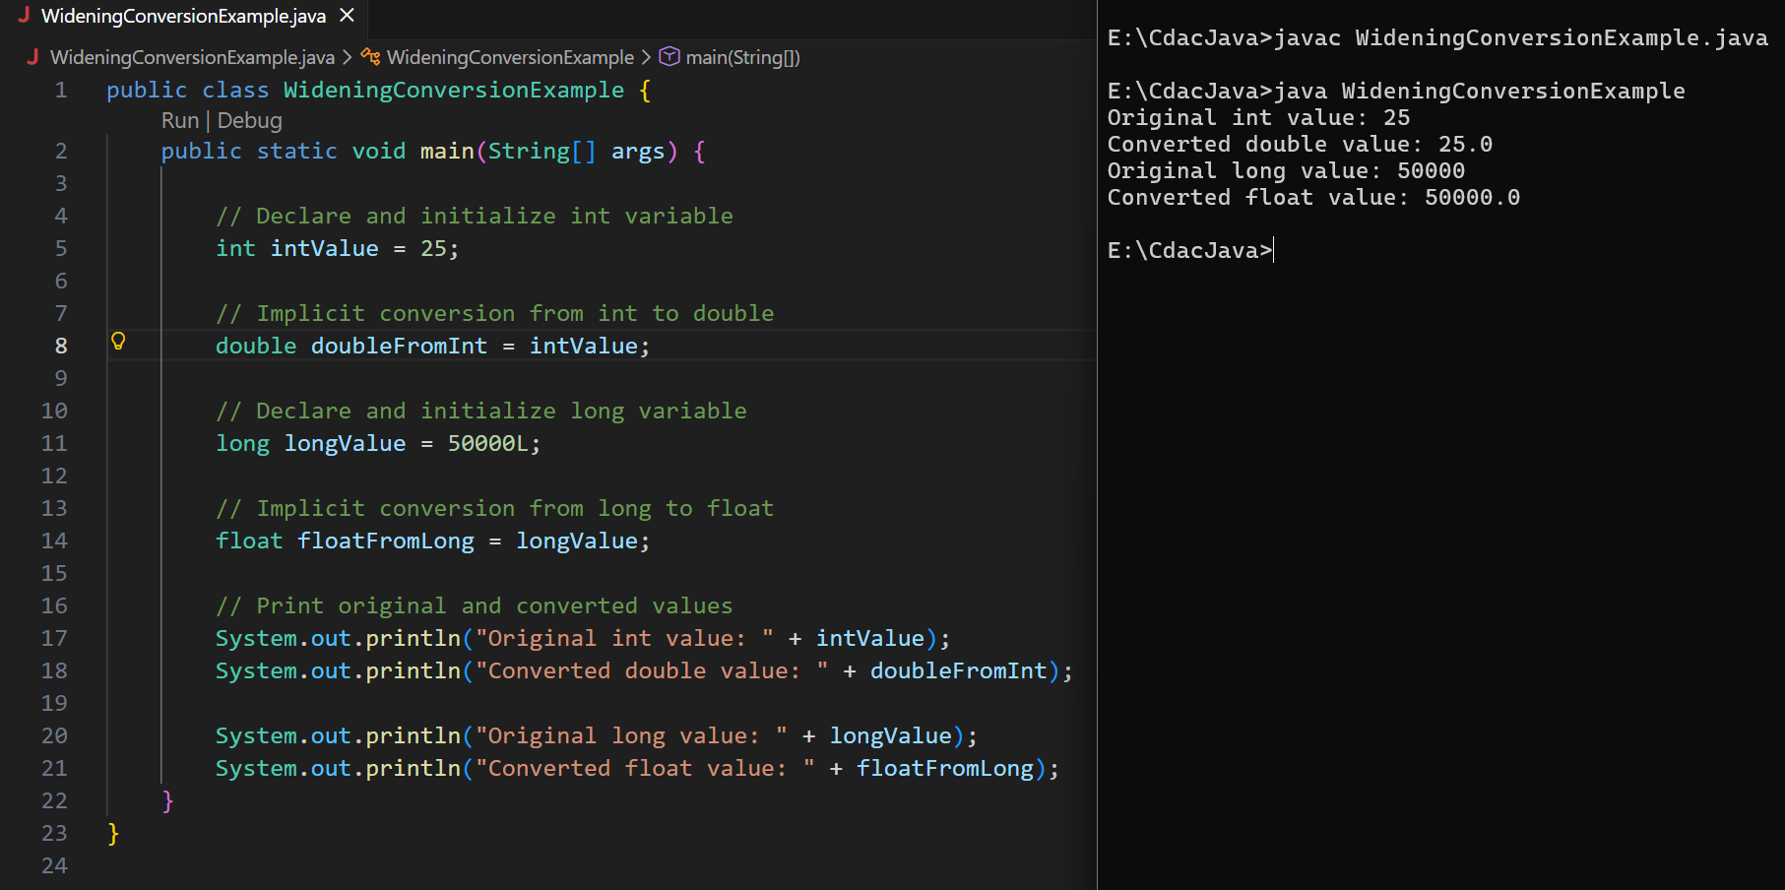
- Print both original and converted values.
Day 1: Assignment-2 (Optional) -Java Programming Fundamentals
Name: Suraj Arya | PRN No.: STT-25128071920
Q5. Add comments to the Q5 code using all two types of Java comments:
a. Single-line comments to explain each line of code.
b. A multi-line comment at the top to describe the overall purpose of the program.
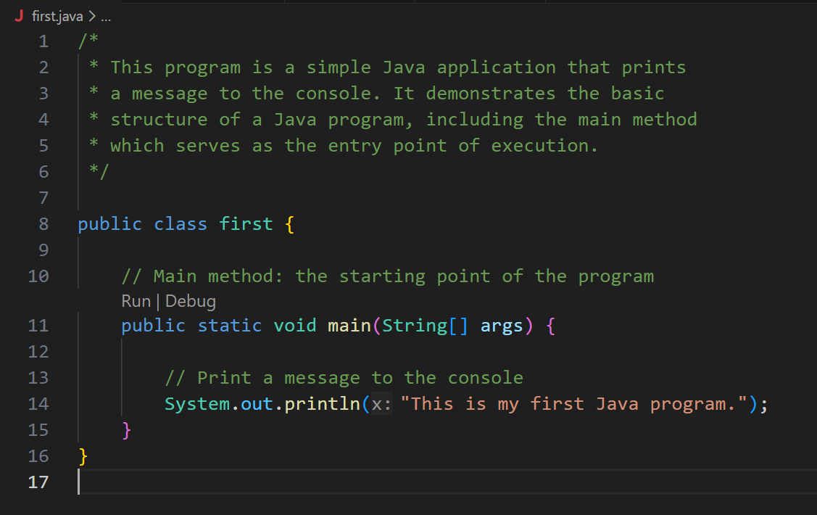
Ans:
Q6. Write a program that declare char variable, Type cast it to int, and prints that int variable.
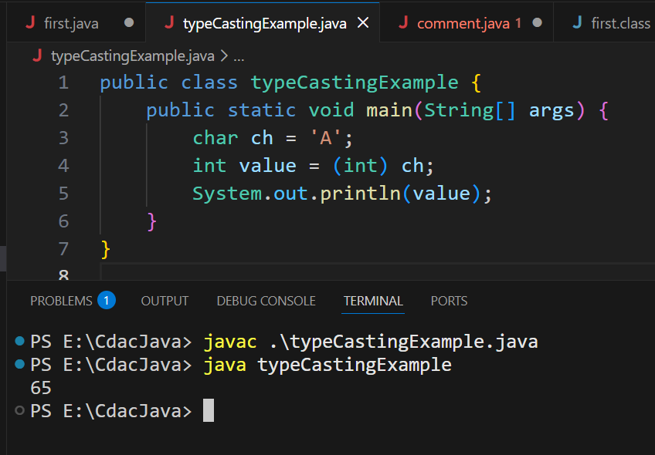
Ans:

Q7. Write a Java program that:
a. Declares a float variable with a decimal value.
b. Type casts it to an int.
c. Prints both the original float value and the converted int value.
d. Shows the data loss (the decimal part is lost) using print statements.
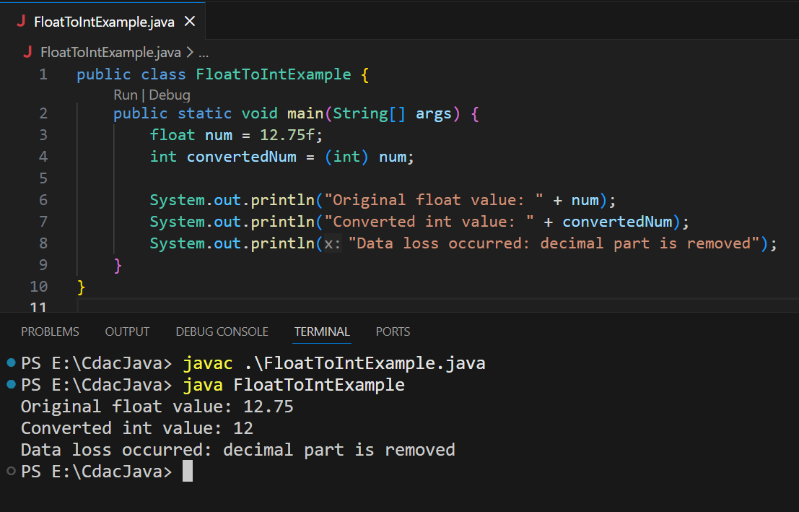
Ans:

